2014 Year-End Close

Budget Execution Instructions

Department of Planning and Budget
May 2014

TABLE OF CONTENTS
Overview 3
About these year-end close instructions 3
The following are definitions of key terms used in these instructions: 3
If you encounter any problems or need specific advice or assistance, please contact your budget analyst. 3
Budget execution year-end close dates 3
Final Appropriation and Allotment Actions 4
Deadline for FY 2014 execution transactions 4
Capital Projects 4
Review of active projects and projects to be closed 4
Capital Project Review Module Instructions 5
Capital Project Review Module Quick Guides 5
Overview Tab Overview 5
The purpose of the Overview tab is to capture the general information about the capital project such as the project type, project status (active or complete), and the estimated completion date. 5
Overview Tab Instructions 5
Project Status Tab Overview 5
Project Status Tab Instructions 5
Submitting Capital Project Review Items 5
Capital Project Review Report 5

Overview

About these year-end close instructions
This package provides instructions to close out FY 2014 from a budget execution perspective, as offered by the Department of Planning and Budget (DPB). Typically, DPB provides instructions for year-end close and new year start-up in one package. However, as of the issuance of these instructions, details regarding the passage of a new budget for the 2014-2016 biennium are not known. New-year startup instructions will be issued separately after more is known about the status of the 2014-16 budget. It should be noted that the Department of Accounts will be distributing a separate memorandum detailing accounting procedures and payroll information for year-end close.
The following are definitions of key terms used in these instructions:
- 2014 Special Session I Appropriation Act means the amended Appropriation Act for the 2012-2014 biennium, as passed by the 2014 Special Session of the General Assembly (Chapter 1, 2014 Special Session I).
- FY 2014 means the fiscal year beginning July 1, 2013, and ending on June 30, 2014.
If you encounter any problems or need specific advice or assistance, please contact your budget analyst.
Budget execution year-end close dates
The significant budget deadlines for year-end close are as follows:
Date | Action
June 12, 2014 | Deadline for agencies to submit capital project review work items in the Performance Budgeting system
June 13, 2014 | Deadline for agencies to submit execution transactions for FY 2014

Final Appropriation and Allotment Actions

Deadline for FY 2014 execution transactions
The deadline to submit budget execution adjustments in the Performance Budgeting system to DPB for FY 2014 appropriation and allotment actions, both operating and capital, is:
5:00 p.m., June 13, 2014
Upon receipt and approval, DPB will process the final FY 2014 actions and transmit them to the Department of Accounts (DOA). Agency pending budget execution adjustments that no longer need processing should be voided in the PB system before the closing date. After this date, agencies will no longer be able to submit FY 2014 budget execution adjustments in the PB system. You will, however, have access to Performance Budgeting system reports after the deadline to allow you to review voided or completed transactions.

Capital Projects

Review of active projects and projects to be closed
All active capital outlay projects, including projects authorized in prior biennia or under §4-4.01.m of the Appropriation Act, must be reviewed to identify projects that have been completed and can be closed out and their appropriation balances reverted, as well as unobligated appropriation balances in active projects that can be reverted.
In connection with this year-end capital review, higher education institutions with Level III status must submit to DPB financial data reports, in lieu of a CARS 1408 report, for all projects that are funded entirely or in part by a general fund appropriation or state tax-supported debt. For these projects for which reports are submitted to DPB, the Level III institutions should follow the same instructions that are applicable to other agencies for closing projects or reverting a portion of their balances.
All such proposed actions must be submitted in the Performance Budgeting system in the Capital Project Review module. Just as with last year, instead of reporting on each capital project, agencies are required to report only on those projects that are ready to be closed out or for which some unobligated balances can be reverted. Also, most of the steps in the Capital Project Review module can be skipped (see the Capital Project Review module instructions for more details).
After identifying which projects can be closed or have some unobligated balances reverted, enter each of those applicable projects, using the Capital Project Review module.
Agencies must complete their entries and submit to DPB no later than June 12, 2014.

Capital Project Review Module Instructions
Performance Budgeting System

The Capital Project Review module is used as part of year-end close activities to help determine the capital budget amounts to be reappropriated in the next fiscal year

To access the Capital Project Review module, select “Capital Project Review” under the “Capital Project Review sub-menu under the “Capital Budget” link on the Performance Budgeting System work tray / main screen.

If you have any questions of a policy nature, please contact your DPB budget analyst. If you experience technical issues with the Performance Budgeting System, please contact the VCCC help desk at vccc@vita.virginia.gov (make sure to indicate in the subject line that you are experiencing a Performance Budgeting system issue so that the ticket can be routed to the Performance Budgeting System help desk).
Capital Project Review Module Quick Guides

AGENCY ANALYST QUICK GUIDE
- Mouse over the Capital Budget Functional Area menu item and select Capital Project Review from the resulting dropdown menu. Once Capital Project Review is selected, the Overview tab will appear.
- Complete the Overview tab as described in the Overview tab instructions.
- Complete the Project Status tab as described in the Project Status tab instructions.
- Click Validate to confirm that the all Business Rules have been satisfied.
- Click Submit and select the appropriate action from the available options.
Continue Working - Saves the Capital Project Review and returns it to the Available to be Claimed tab on the Work Tray for users with similar credentials to claim.
Submit for Agency Review - Submits the Capital Project Review to the first level in the Agency Reviewer step of the workflow.
NOTE: This submit action will be displayed only if the selected Agency has assigned Agency Review steps.
Ready for DPB Bulk Submit - Submits the Capital Project Review to the ?holding area? for later submission to DPB in bulk.
NOTE: This submit action will be displayed only if the selected Agency does NOT have Agency Review steps.
Void Document - Voids the Capital Project Review.

AGENCY REVIEWER QUICK GUIDE
- Click on the Available to be Claimed tab in the Work Tray.
- Select the Document Type filter and select Capital Project Review to filter on the Capital Project Review.
- Click the Apply button to filter the work items displayed in the work tray by the selected document type(s).
- Click Claim next to a Capital Project Review that is ready for review. Once Capital Project Review is claimed, the Overview tab will appear.
- Review the Overview tab for completeness and accuracy according to the instructions issued by DPB.
- Click on the Project Status tab and review for completeness and accuracy according to the instructions issued by DPB.
- Click Submit and select the appropriate submit actions from the available options.
Return for Further Data Entry - Returns the Capital Project Review to the data entry workflow step.
Ready for DPB Bulk Submit - Submits the Capital Project Review to the holding area for later submission to DPB in bulk.
Void Document - Voids the Capital Project Review.
Continue Review - Saves the Capital Project Review and returns it to the Available to be Claimed tab on the Work Tray for users with similar credentials to claim.
Return to Previous Submitter - Returns the Capital Project Review to the agency reviewer role that previously submitted the work item to Agency Review.
Note - This submit action will be displayed only if the Agency has multiple Agency Review steps assigned.

Overview Tab

Overview Tab Overview
The purpose of the Overview tab is to capture the general information about the capital project such as the project type, project status (active or complete), and the estimated completion date.
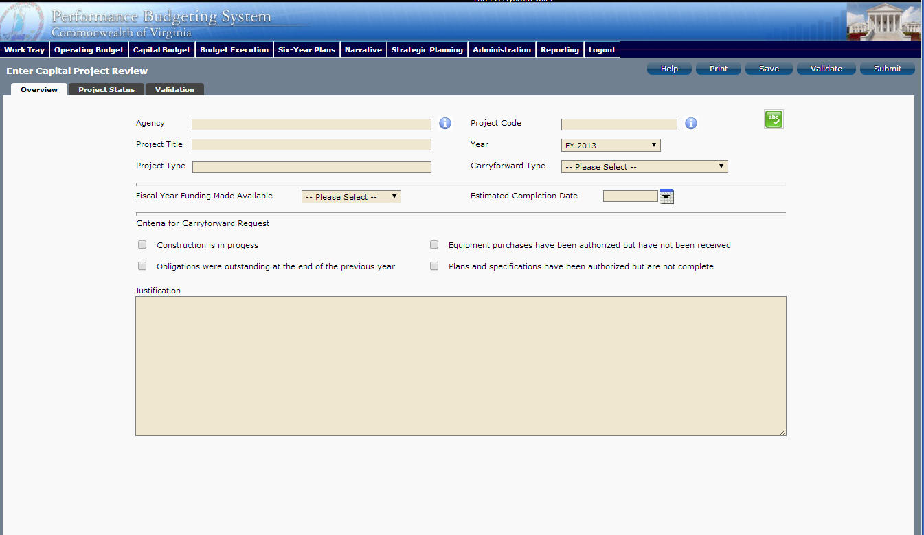
Overview Tab Instructions
- Click on the Overview tab.
- Select the Agency of the capital project for which you would like to prepare a Capital Project Review. The active projects for the selected agency will be available for selection in the Project Code field.
- Select the Project Code of the capital project for which you would like to prepare a Capital Project Review. (Note-you only need to prepare a capital project review for projects being closed or projects where you are proposing a partial reversion at year-end)
- The fiscal year should pre-populate to the current fiscal year.
- Select the Carryforward Type for the capital project balance using the dropdown arrow.
Select “B: Active, Partial Reversion” if the project is to remain active, but some balances can be reverted. Select “C: Project Complete” if the project is to be closed and all balances reverted. (If a project falls under the “A: Active, Carryforward All Balances” category (remain active and no balances reverted), no action is needed. You do not need to complete a capital project review work item for carryforward type “A” projects.).
- You may skip the remaining fields on the Overview tab.

Project Status Tab

Project Status Tab Overview
The purpose of the Project Status tab is to identify amounts to be reverted for projects being closed or projects where a portion of the appropriation will be reverted at year-end.

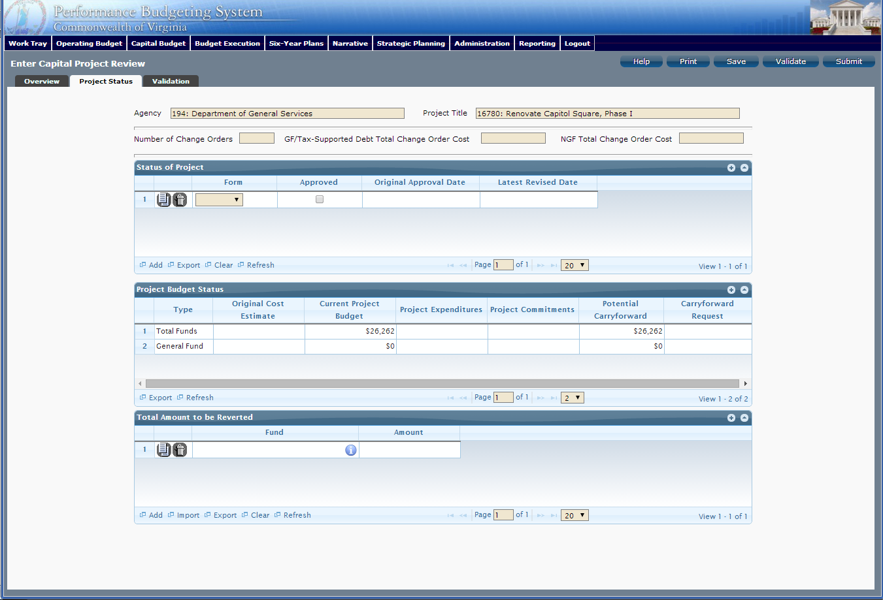
Project Status Tab Instructions
- Click on the Project Status tab.
- “Status of Project” Section—You may skip this section.
- “Project Budget Status” Section—You may skip this section.
- “Total Amount to be Reverted” Section.
- If you selected “B” (active, partial reversion) in the Carryforward type field, enter each applicable fund detail code and the amount to be reverted.
- If you selected “C” (closed, complete reversion) in the Carryforward type field, enter each applicable fund detail code and amount of the balance anticipated to be available on June 30, 2013. (For projects designated to be closed, the Department of Accounts will revert the entire June 30 balance.)

Submitting Capital Project Review Items

- You will use the Capital Project Review Bulk Submit module to submit all of your Capital Project Review work items to DPB at one time. To access the Capital Project Review Bulk Submit module, select “Capital Project Review Bulk Submit” under the “Capital Project Review sub-menu under the “Capital Budget” link on the Performance Budgeting System work tray / main screen.
- To ensure that all requests are accounted, for look at the Document Title column to review the Capital Project Review work items.
- To bulk manage the submit action, click the Set all to dropdown and select the submit action that the work items require: Submit to DPB, Continue Review or Return to Previous Submitter. For submitting to DPB, all work items must be set to Submit to DPB.
- Confirm that the Step Title and State fields are correct for each of the work items.
- Click the Submit button. A message will display in the text box below the submit button that will alert the user that the submit action was successful.

Capital Project Review Report

You may run a report of your Capital Project Review submissions by clicking on the “BE2.40 - Capital Project Review” report within the Performance Budgeting system reports menu. This report contains a simple listing of active capital projects along with an indication of whether a Capital Project Review work item has been completed for a project.
